Ancient India

HARAPPANS: - Indus River Valley ~ 2500 BCE
- River fed by snow from the Himalayas Mountains
  - “Himilayas” means “home of snow” in the ancient Sanskrit language
- People used river for fresh water, food (fishing), transportation & farming
- Floods each year brought sediment/silt to the river valley
- Because of annual flooding, people invented ways to control the river
  - Levees/dams/dikes, irrigation
- fertile soil and good farming
  - Farmers grew barley, wheat, peas, melons, dates
  - First to grow cotton and use it to weave & dye cloth
Cities
- Built cities on mounds to avoid the floods
- Used sun-dried and kiln-fired bricks in construction
- Twin capital cities – Harappa & Mohenjo-daro
  - Planned communities
  - Streets laid out in a grid – uniform network, right-angle corners
  - Homes built around central courtyards
  - Homes had wells, drains, bathrooms
- A protected citadel on the highest ground contained the “Great Bath” and a huge granary (or hall)
  - Great Bath may have been used for religious purposes
  - Granary may have been used to store goods
  - No one really knows!
Evidence of Harappan Civilization
- Archaeological sites at the ruins of Harappan & Mohenjo-daro
- Artifacts
  - Jewelry – gold & lapis lazuli
  - Tools & weapons of stone, copper and bronze
  - Clay models of animals, rattles, dice, toy wheeled carts
  - Carved seals depicting animals and writing
Decline of the Harappans (1700-1200 BCE)
- Buildings and artifacts show a decline in care and quality over time
- Did the soil and natural resources become depleted?
- Did deforestation cause more flooding and leave no fuel for fires?
- Did the climate or geology change the flow of rivers?
- Did outsiders invade?
No one knows for sure, because we haven’t yet deciphered Harappan writing!

By 1200 BCE, the Aryans (“from the North”) had taken over the Indus River Valley.
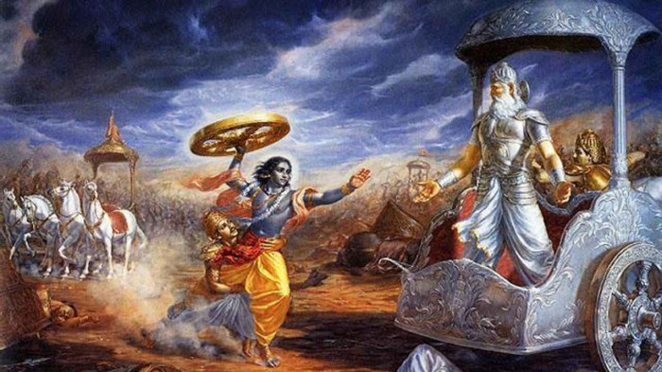

THE VEDIC PERIOD ~ 1500 BCE – 500 BCE
- Aryans from the Black Sea/Caspian Sea area migrated all over Eurasia, becoming Romans, Greeks, Hittites, Persians
- Aryans arrived in the Indus Valley about 1500 BCE, settling and mixing with the local Indian people
- Aryans brought with them their Vedic gods and beliefs, the domesticated horse, and the written Sanskrit language
- The blending of Harappan beliefs and Vedic beliefs gave rise to Hinduism
- About 800 BCE they learned how to use iron
- With the advantage of iron weapons, the Vedic people expanded south and east into the Ganges River valley – this story is told in the MAHABHARATA
- during this period southern India was ruled by numerous independent kings – stories of the battles between the Vedics and these kings are told in the RAMANYANA
- In the 500’s BCE, Persians conquered north-western India, and the Vedics formed a larger empire in north-eastern India. This was a time “where big fishes ate little fishes”!
HINDUISM
- The word “Hindu” means “people who live near the Indus river”
- The Harappans carved images of several gods that look a lot like the Hindu gods Shiva and Vishnu
- The Aryans brought Indo-European sky gods and the written language Sanskrit
The Rig Veda
- A long Sanskrit poem composed about 1000 BCE, written down in 300 BCE
- Tells the story of Prajapati, the first god who created the whole universe out of his body
- Mentions many different gods (polytheism), and contains hymns, magic spells, and animal sacrifice instructions
Reincarnation
- About 600 BCE, belief in reincarnation became popular.
- Hindus believe that after you die you are reborn into another body. If you led a good life, you will come back in a better form – if you led a bad life, you will come back in a worse form
- Reincarnation made the idea of animal sacrifice less appealing, and by about 300 BCE people began to worship new gods who did not demand animal sacrifice and instead wanted flowers, incense, prayers and music.
THE CASTE SYSTEM
- According to the Rig Veda, Prajapati created four groups of people when he created the world:
  - Priests and teachers were cast from his mouth (Brahmins)
  - Rulers and warriors from his arms (Kshatriyas)
  - Merchants and traders from his thighs (Vaishyas)
  - Workers and peasants from his feet (Sudras)
- Outcasts who did all the “dirty” work fell into the “Untouchable” class
- Physical contact was forbidden between Brahmins and Untouchables – a Brahmin would wash if they were touched by the shadow of an Untouchable!
- These ranked classes organized society – there was no social mobility across caste.
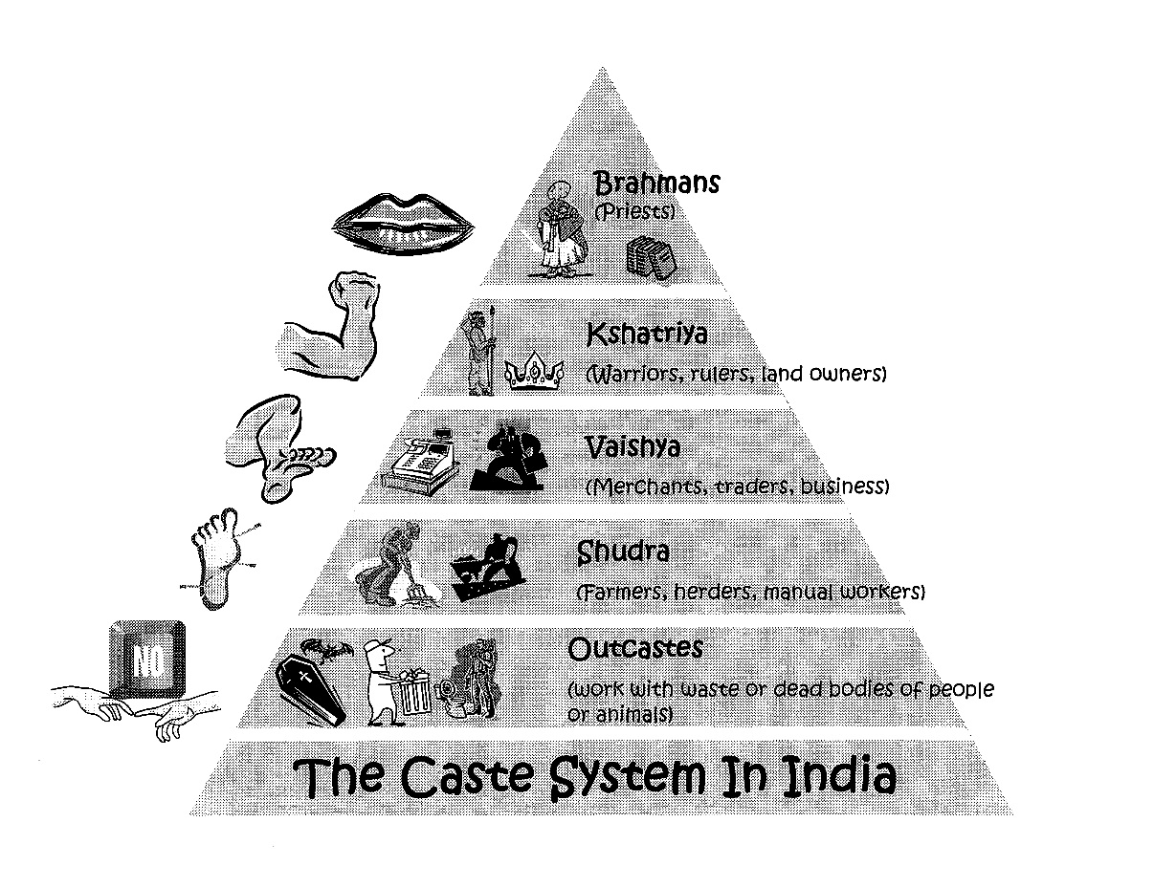
GREEKS, THE MAURYAN EMPIRE & ASHOKA (325 BCE – 185 BCE)
- In 325 BCE, Alexander the Great conquered the Persian Empire (including north-west India)
- Alexander went back to Babylon, but he left behind thousands of Greek soldiers, writers, artists, sculptors and teachers.
- With the Greeks gone, Chandragupta was able to overthrow the old Vedic kingdom and establish a new empire over northern India and into Afghanistan, retaking the Indus valley.
- Two generations later, in a series of bloody battles, Chandragupta’s grandson, Ashoka extended the empire to include parts of southern India.
- Ashoka was so shaken by the carnage that he renounced warfare and Hinduism and converted to Buddhism. He convinced millions of others all over central Asia to follow his lead.
- Ashoka died in 231 BCE. By 185 BCE the Mauryan Empire had slowly fallen apart and small kingdoms again arose throughout India.
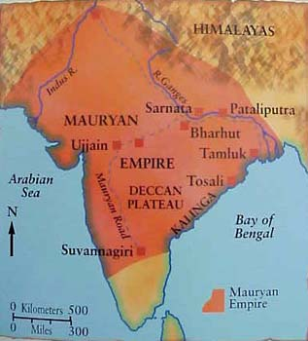

THE RISE OF BUDDHISM
- By the 6th century BCE, members of the Hindu castes lower down the social pyramid were becoming upset at the overwhelming power of the Brahmins and the corruption they perceived in the system
- some people started to question humanity’s place in the universe, animal sacrifices, and other Vedic rituals
Siddhartha Gautama
- Siddhartha Gautama was a prince born in the 6th century BCE
- after a sheltered childhood and early adulthood spent in the palace, he went out into the world and discovered poverty, misery, and illness.
- Disenchanted with his life, he gave away his wealth and searched for years for enlightenment by studying, meditating, and enduring pain and fasting.
- He finally rejected the ascetic life and decided to follow a balanced “Middle Path”; after meditating for many days under a Bodhi tree, he found the answers to his questions about suffering and the universe
- He became the Buddha – “he who is awake” – and started preaching about the “Four Noble Truths” and “the Eightfold Path”

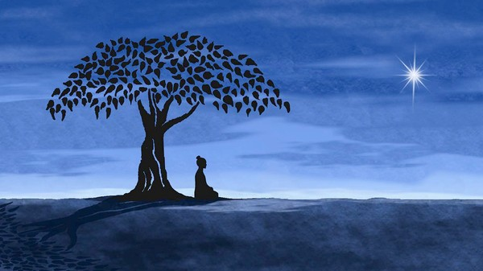
Buddhism: The Four Noble Truths
- the Truth of Suffering
- the Truth of the Cause of Suffering
- the Truth of the End of Suffering
- the Truth of the Path Leading to the End of Suffering
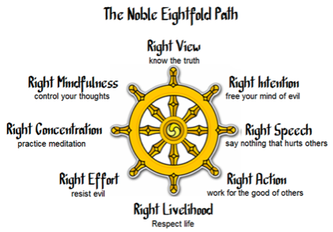
The Steps of the Eightfold Path
- Right Understanding: To understand the Law of Cause and Effect and the Four Noble Truths.
- Right Attitude: Not harboring thoughts of greed and anger.
- Right Speech: Avoid lying, gossip, harsh speech and tale-telling.
- Right Action: Not to destroy any life, not to steal or commit adultery.
- Right Livelihood: Avoiding occupations that bring harm to oneself and others.
- Right Effort: Earnestly doing one's best in the right direction.
- Right Mindfulness: Always being aware and attentive.
- Right Concentration: To making the mind steady and calm in order to realize the true nature of things.

MEDICINE
- medical textbooks from as far back as 1000 BCE and 500 BCE explain how to treat diseases and surgical methods for pulling teeth, extracting cataracts from eyes, fixing broken bones, and clearing blocked intestines
METALS
- The commonly used metals in ancient times include gold, silver, copper, iron, tin, lead, zinc and mercury.
- The Indus Valley civilization entered the Bronze Age about 3000 BCE and the Iron Age about 1000 BCE; by around 250 BCE a kind of steel was being produced in India
MATHEMATICS - “Famous for Nothing!”
- the Harappans developed standard weights based on the number 10
- by 1800 BCE Indian mathematicians were discussing the idea of infinity
- by 1300 BCE Indian astronomers were using geometry to write rules explaining the movement of the sun and moon
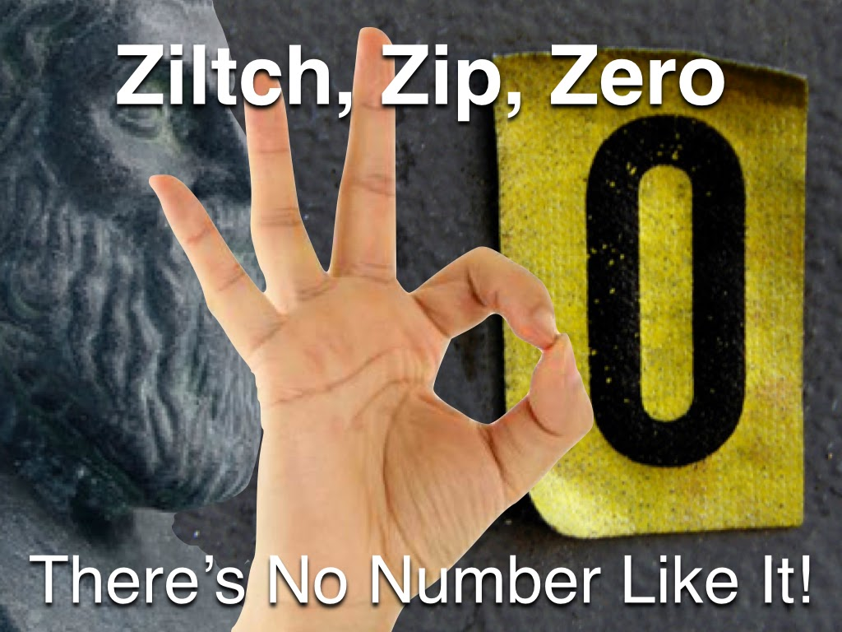
- by 300 BCE Indian mathematicians were working on combinations and probability
- Indian mathematicians invented the numerals we use today, the decimal system, and the use of zero as a placeholder to make it easier to add and multiply numbers; “zero” is actually Sanskrit for “nothing”!

