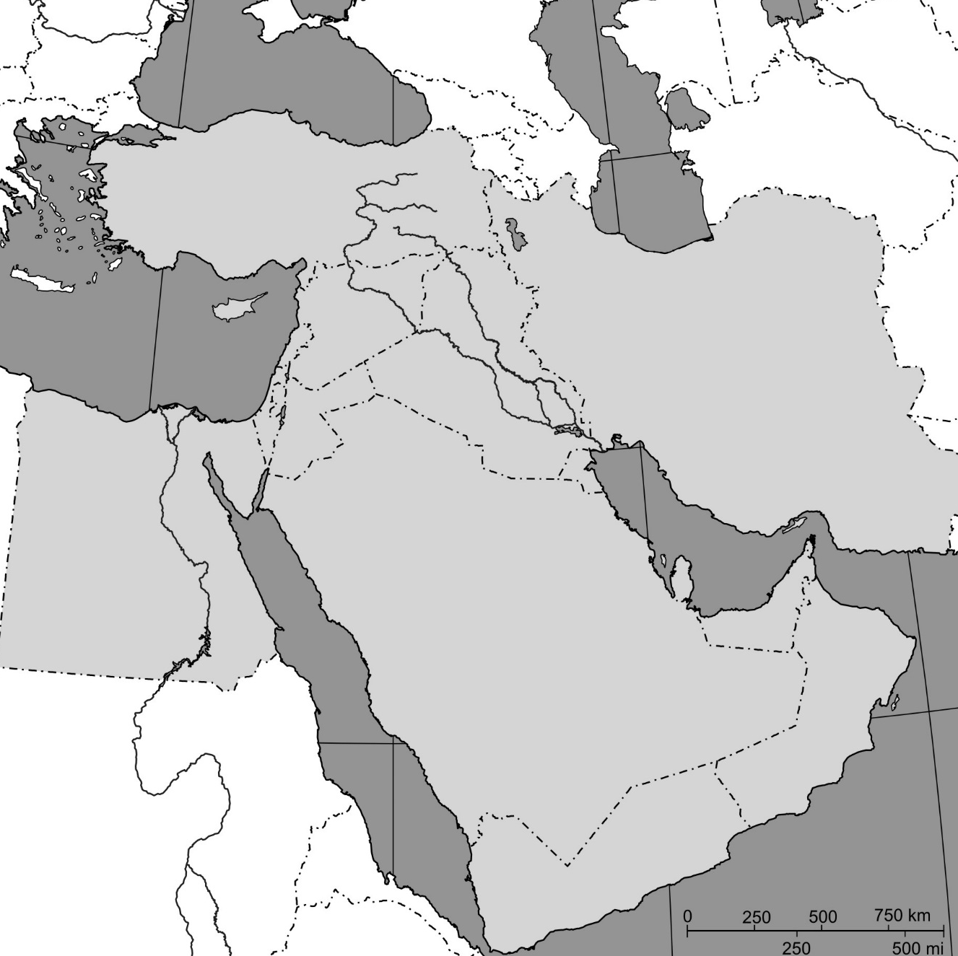
Countries/Capitols:
Bahrain/Manama
Cyprus/Nicosia
Egypt/Cairo
Iran/Tehrān
Iraq/Baghdād
Israel/Jerusalem
Jordan/’Ammān
Kuwait/Kuwait
Lebanon/Beirut
Oman/Muscat
Qatar/Doha
Saudi Arabia/Riyadh
Syria/Damascus
Turkey/Ankara
United Arab Emirates/Abu Dhabi
Yemen/Sanaa

Bodies of Water:
Aegean Sea
Black Sea
Caspian Sea
Euphrates River
Gulf of Aden
Gulf of Oman
Mediterranean Sea
Nile River
Persian Gulf
Red Sea
Tigris River
Bab-el-Mandeb (Gateway of Tears)

